Faculty of Computer Science & Engineering
Project Report on

Smart Vacuum Cleaner

Course Title: Computer Peripheral and Interfacing Sessional
Course Code: CCE 322

Submitted by
Sinthiya tabashoum
ID: 1902070
Reg: 08776
Level – 3 Semester – 2
Session: 2019-2020

Submitted to
Sarna Majumder
Associate Professor
Department of Computer and Communication Engineering
Faculty of Computer Science and Engineering

Arpita Howlader
Assistant Professor
Department of Computer and Communication Engineering
Faculty of Computer Science and Engineering

Patuakhali Science & Technology University,
Dumki, Patuakhali, Bangladesh.
Title:
Design and Development of a Smart Vacuum Cleaner with Auto Obstacle Detection, Cleansing, Self-Repairing Capabilities and Location Tracking

1. Introduction
Technological advancements have revolutionized how household chores are performed, and the demand for automation in cleaning tasks has seen a sharp rise. Traditional vacuum cleaners, although effective, require manual intervention, which can be time-consuming and labor-intensive. In contrast, smart vacuum cleaners automate the cleaning process, making them highly efficient and reducing human effort. This project focuses on the design and development of a Smart Vacuum Cleaner that features automatic obstacle detection, autonomous cleaning, and self-repair functionality through a servo motor. Additionally, it can visualize its path and location on a computer screen via a Wi-Fi module.

2. Objective
The primary objective of this project is to design and build a fully functional Smart Vacuum Cleaner that can:
- Detect obstacles and avoid collisions.
- Perform autonomous cleaning tasks efficiently.
- Self-repair using a servo motor to fix itself when it faces imbalancing.
- 4. Visualize and simulate the state of the car on real time using a Wifi module called esp8266 on a webserver()

3. Problem Statement
Many people preferred manual vacuum cleaners over robotic vacuum cleaners because these cleaners are costly compared to the normal ones. Adding to this few people also said that robotic vacuum cleaners are inefficient compared to the manual ones and also few said that their minute small objects were sucked by robotic vacuum cleaners while on the other hand few were ready to remove the objects before cleaning so that it won’t remain as an obstacle to their robot. Following are the list of problems analyzed:
For non portable Vacuum cleansers:
1.Manually controlled
2.Constant connection with power supply
3.Consume more power

There are some portable one but has some limitations,
1.Can not be monitored from remotely
2.If it get upside down don’t have power to restable

4. Features of the Smart Vacuum Cleaner
- Obstacle Avoidance: The ultrasonic sensor enables the vacuum cleaner to automatically detect and avoid obstacles during operation.
- Suction System: A DC motor-powered vacuum fan provides suction for cleaning purposes.
- Stability Monitoring: The MPU6050 sensor tracks the vacuum's orientation (x, y, and z axes) to determine its stability. If the vacuum cleaner flips upside down, a buzzer sounds an alarm.
- Automatic Recovery: When the vacuum is upside down, a servo motor is programmed to automatically engage to restore the vacuum's position. However, this feature is currently non-functional due to insufficient battery power.
- Remote Monitoring: I am working on sending real-time data to a web server, allowing remote monitoring of the vacuum cleaner's performance.

5. Equipment Used
I have developed a self-controlled, automatic obstacle-avoidance vacuum cleaner using the following components: HC-SR04 Ultrasonic Sensor, Servo Motor SG90, L293D Motor Driver Shield, Raspberry Pi Pico, MPU 6050 3-Axis Gyro (6DOF), and a vacuum fan.

- Raspberry Pi Pico: Acts as the brain of the vacuum cleaner, controlling the motors, sensors, and Wi-Fi communication.The Raspberry Pi Pico serves as the central controller for the smart vacuum cleaner. It processes signals from the sonar sensor and commands the motors to adjust movement based on the surrounding environment. It also handles communication with the Wi-Fi module to send location data to a computer for real-time visualization.
How it works:
The Pico collects input from sensors (like the sonar sensor), processes the data, and sends signals to the motors, fan, and other components to execute actions such as obstacle avoidance, movement, and cleaning. It also communicates wirelessly with the user’s computer through the Wi-Fi module.

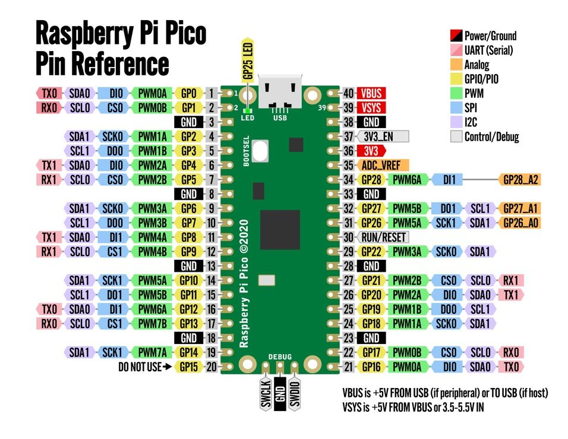
Fig : Raspberry Pi Pico

- Servo Motor: For self-repair mechanisms.The servo motor is used for precision tasks, such as making small adjustments to mechanical components. It helps the vacuum cleaner self-repair minor mechanical issues, like realigning parts or fixing small malfunctions.
How it works:
When a mechanical issue is detected, the Raspberry Pi Pico activates the servo motor, which moves to correct the problem (e.g., fixing a misaligned wheel). The servo operates by rotating a set number of degrees to make precise adjustments.
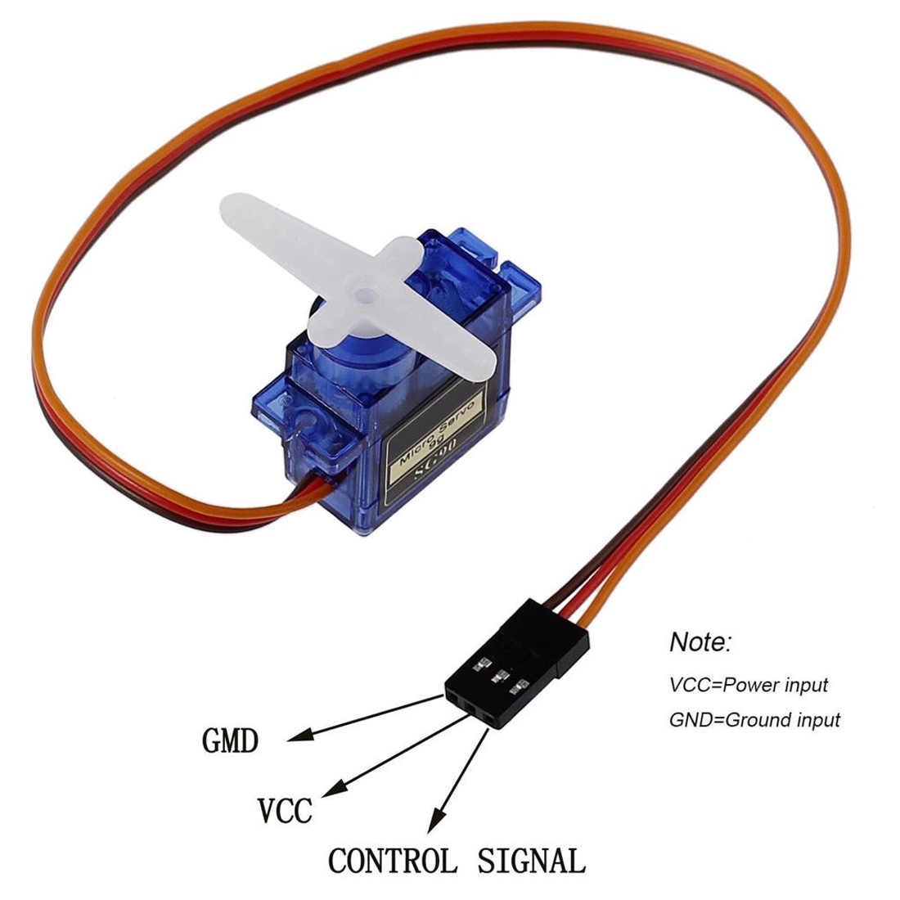
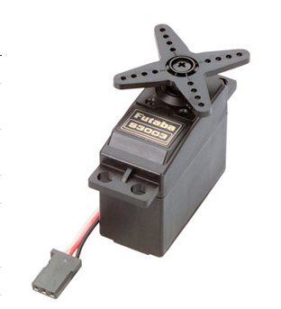
Fig : Servo Motor
- 4 DC Motors: For driving the vacuum cleaner’s movement.The vacuum cleaner uses these motors to move forward, backward, and turn. They are attached to the wheels and controlled by the Raspberry Pi Pico based on inputs from the sonar sensor.
How it works:
The DC motors drive the vacuum cleaner by converting electrical energy into mechanical movement. The Pico controls the motors' speed and direction, allowing the vacuum cleaner to adjust its path when obstacles are detected or when moving around.

HC-SR04 Ultrasonic Sensor: To detect obstacles and aid in navigation.This ultrasonic sensor measures the distance to objects by emitting sound waves and timing how long they take to bounce back. The sensor allows the vacuum cleaner to detect obstacles ahead.
How it works:
The sensor sends sound waves, and when they reflect off an object, it calculates the distance. If the object is too close, the Raspberry Pi Pico signals the motors to change direction to avoid a collision.
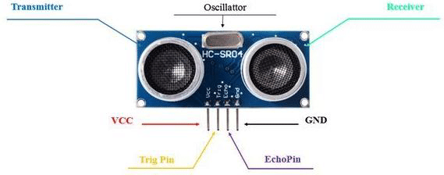
Fig : Ultrasonic Sensor
- Vacuum Fan: Responsible for the cleaning action.The fan is responsible for creating suction, which helps pick up dust and debris from the floor. It operates whenever the vacuum cleaner moves over an area to ensure effective cleaning.
How it works:
As the vacuum cleaner moves, the fan spins to generate suction, pulling dirt and debris into a collection chamber. The fan is powered by the 3.7V battery and controlled by the Pico.
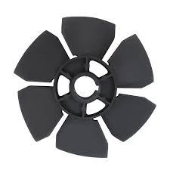
Fig : Vacuum Fan
- 3.7-volt Battery: To power the system.This rechargeable battery powers all the components, including the Raspberry Pi Pico, motors, fan, and sensors. It is designed to provide long-lasting energy to the vacuum cleaner during its autonomous operation.
How it works:
The battery supplies electrical power to the entire system. It is connected to the Pico, which distributes power to the motors, sensors, and other components as needed.

- Wi-Fi Module: For wireless communication and visualizing the path of the cleaner on a computer.The Wi-Fi module allows the vacuum cleaner to communicate with a computer wirelessly. It transmits location and movement data, enabling the user to track the cleaner's position in real-time.
How it works:
The Wi-Fi module connects to the home network and sends data from the vacuum cleaner to a computer. This data is visualized on a graphical interface, showing the cleaner's location and movement path as it navigates the environment.
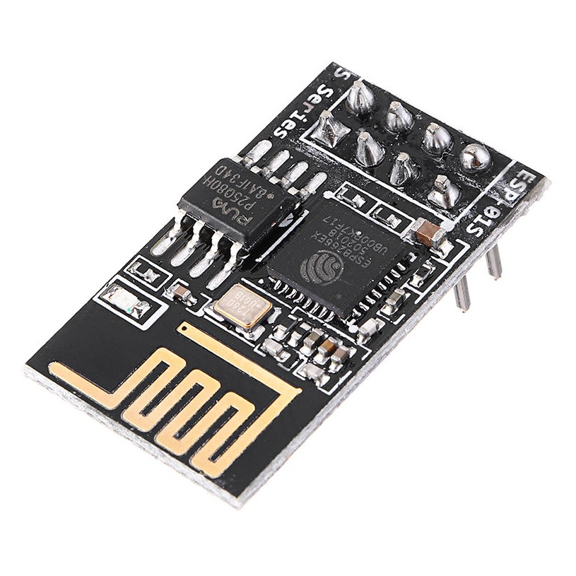

Fig : Wi-Fi module

L293D Motor Driver Shield For Arduino:The L293D is a dual-channel H-Bridge motor driver capable of driving a pair of DC motors or single stepper motor. As the shield comes with two L293D motor driver chipsets, that means it can individually drive up to four DC motors making it ideal for building four-wheel robot platforms. In my project i used this to control 4 motors and two servo motors. One is for controlling the ultrasonic sensor and other is for controlling the self balancing system.

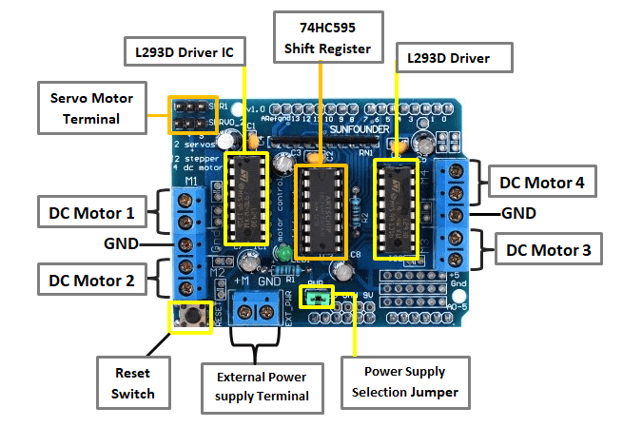

Fig :L293D Motor Driver

MPU 6050 3 Axis Gyro 6DOF :The MPU-6050 is a serious little piece of motion processing tech! By combining a MEMS 3-axis gyroscope and a 3-axis accelerometer on the same silicon die together with an onboard Digital Motion Processor™ (DMP™) capable of processing complex 9-axis MotionFusion algorithms, the MPU-6050 does away with the cross-axis alignment problems that can creep up on discrete parts.
In my project the MPU8266 accelerometer calculate the value of x,y and z axis. And find out whether the vacuum cleaner is stable or upside down.

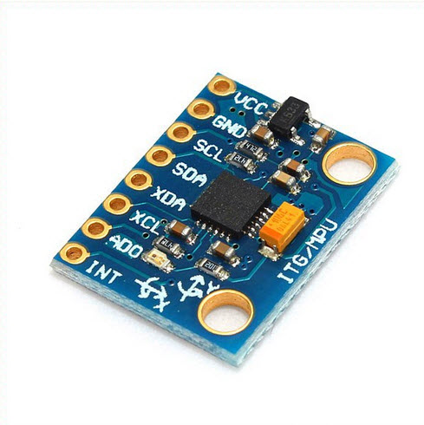

Fig : MPU 6050 accelerometer

6. Methodology:

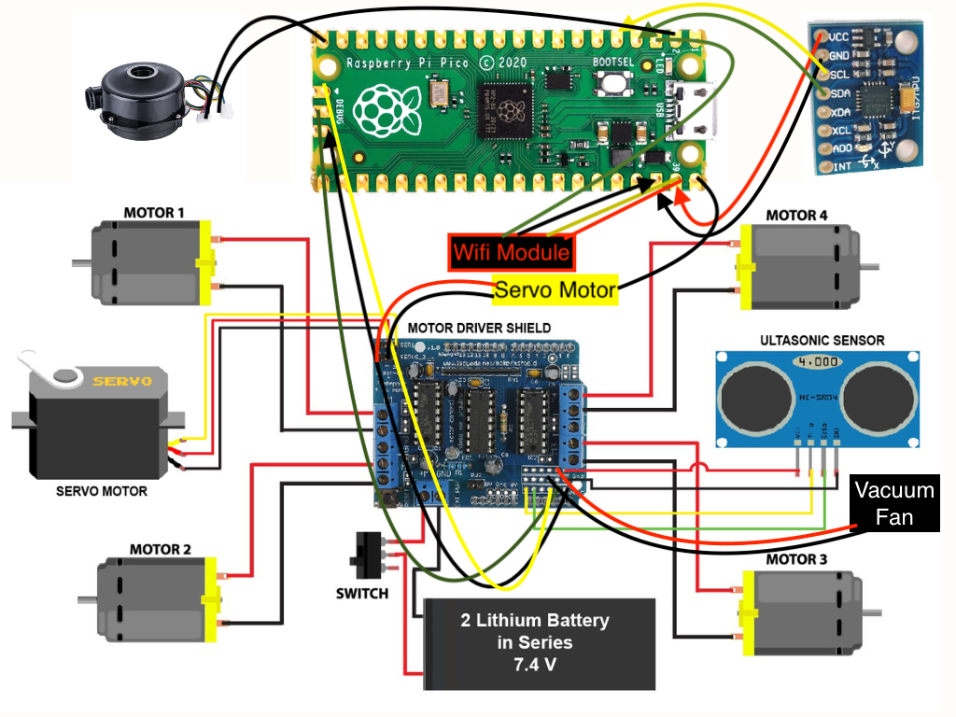

Figure : Circuit Diagram Of Vacuum Cleaner

Sonar Sensor: Detects obstacles using ultrasonic waves (eco and trigger), guiding the vacuum to avoid collisions.
MPU 6050 (3-axis Gyro 6DOF): Monitors the vacuum’s movement across the X, Y, and Z axes. It provides real-time data on the system's orientation, ensuring stability and smooth operation.
L293D Motor Driver Shield for Arduino: Controls the four DC motors responsible for driving the wheels and also manages two servo motors—one for adjusting the direction of the sonar sensor, and the other for the self-balancing system.
Wi-Fi Module: Sends real-time data to a server, allowing users to remotely visualize the vacuum's movement and status from any location in the world via an online interface.
Servo Motors:
- Servo 1: Adjusts the orientation of the sonar sensor for optimal obstacle detection.
- Servo 2: Activates during imbalance to help stabilize the system using a self-balancing mechanism.
Raspberry Pi: Serves as the brain of the system, processing sensor inputs, controlling motor outputs, and managing wireless communication.
Arduino UNO: Primarily acts as a power supplier for the components.
Vacuum Fan: Provides suction to clean dust from surfaces.
DC Motors: Four motors power the movement of the vacuum, making it suitable for a four-wheel robot platform.
3.7-Volt Battery: Powers the entire system.
Buzzer: Alerts users when the vacuum experiences imbalance or errors.

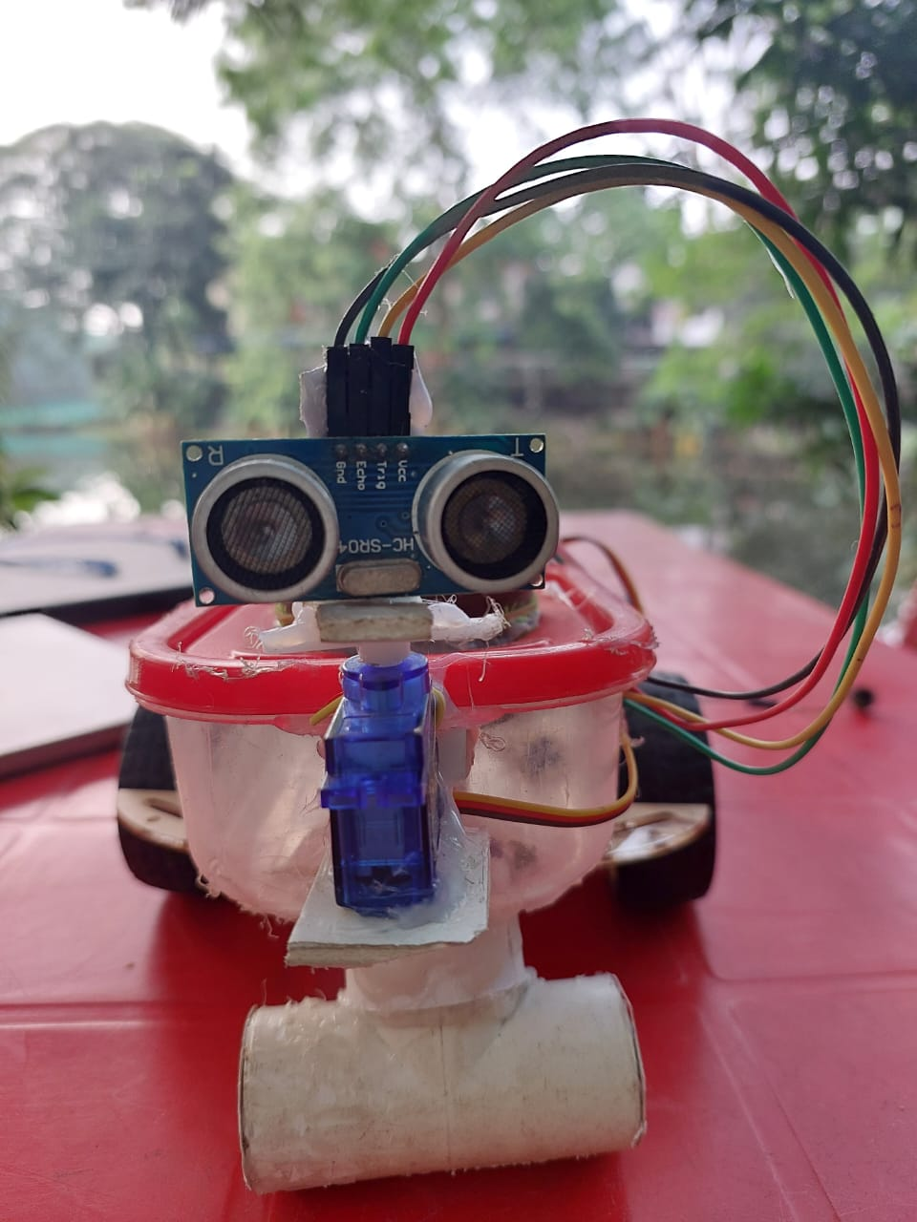

Fig : Implemented Vacuum Cleaner (front)
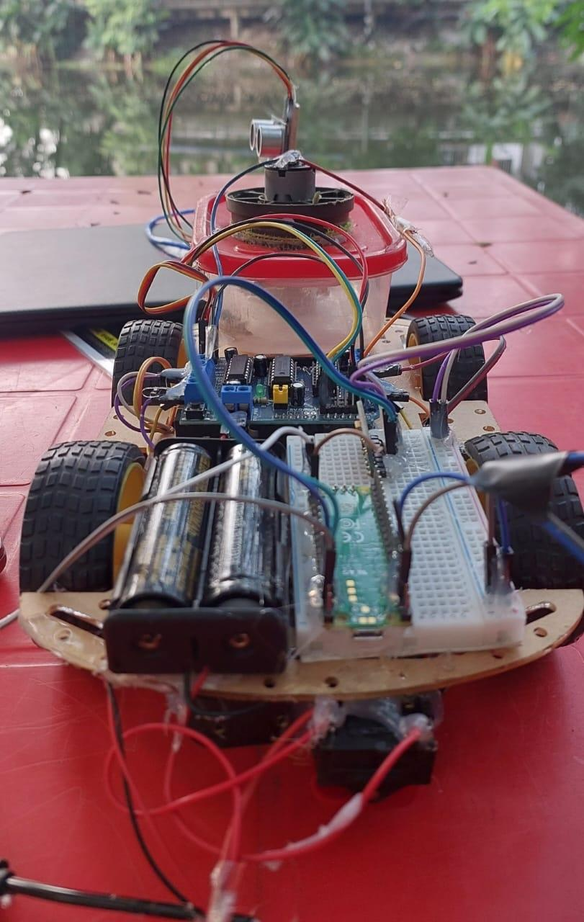

Fig : Implemented Vacuum Cleaner

Navigation System: Navigation system is nothing but the way, the robotic vacuum cleaner plans to plot a path and avoids the obstacles for itself. It represents the algorithm used for obstacle avoidance during the operation of automatic vacuum cleaning robot. 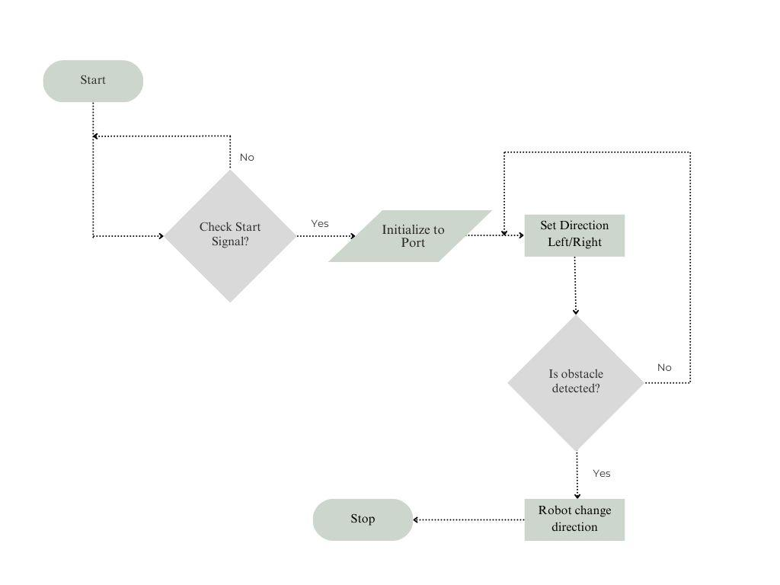
Figure1 :Algorithm used for Obstacle Avoidance.

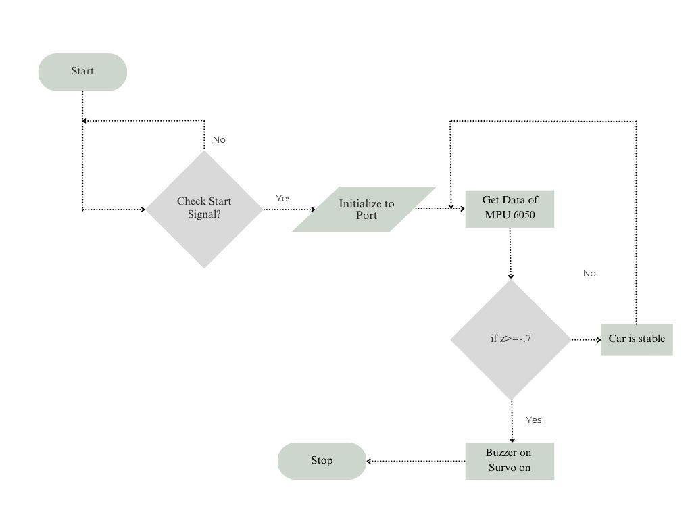
Fig2: Flowchart for visualize the state of the car

7.SIMULATION
Obstacles Avoidance Simulation and Vacuum analysis:
The main objective in this phase of the report is to develop and run simulation for the vacuum cleaner which has a proper path and can run smoothly by avoiding the obstacles ,it does avoid overturning ,also can turn on buzzer if it overturns . This simulation was done and can be shown on screen. A sample test one has been put up, developed a simple path where if it overturns,what will be happened is shown :
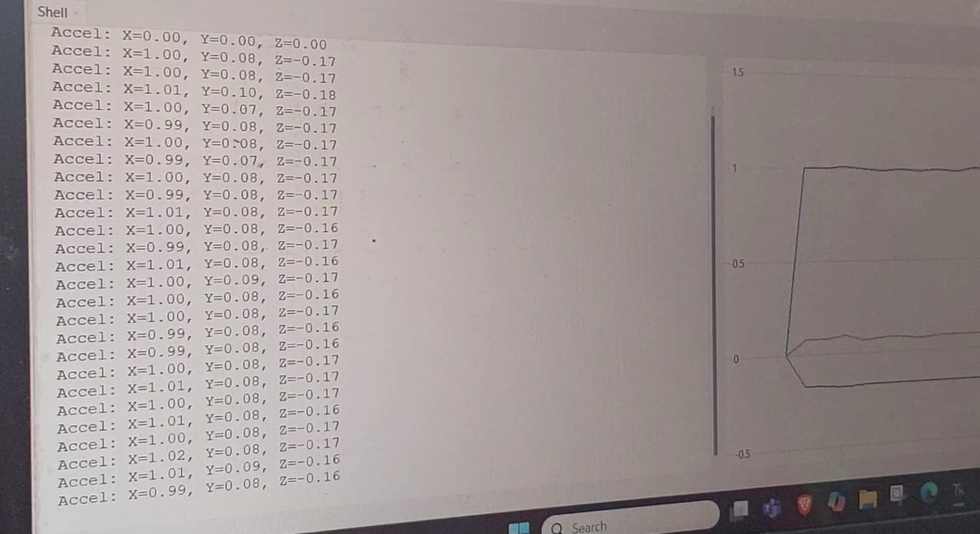
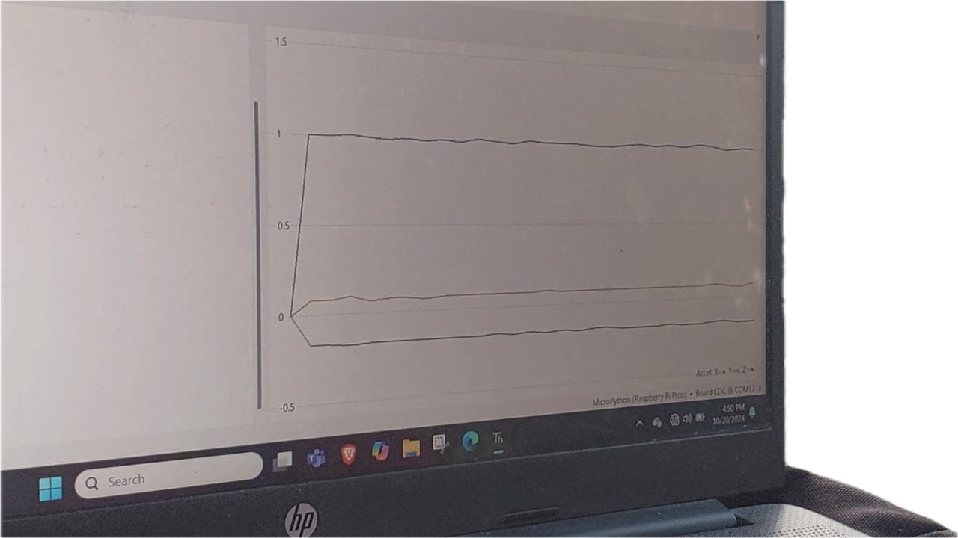

It shows the graphical visualization of (x,y,z axis) car , when car is in stable situation.
Now,

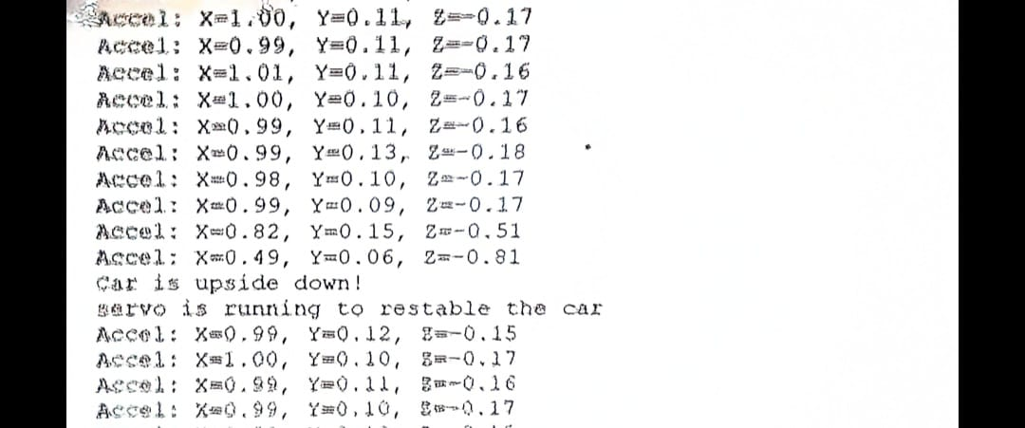
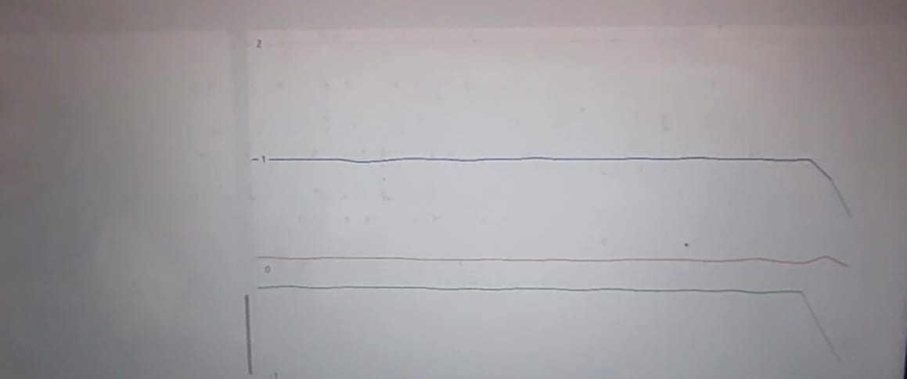
It shows the graphical visualization of (x,y,z axis) car , when car is not in stable situation or overturns .

7. Result
Successes:
- Obstacle Detection: The vacuum cleaner successfully detects obstacles using the sonar sensor and avoids them while navigating the room.
- Dust Suction and Cleaning: The vacuum fan efficiently cleans the floor by sucking dust and debris.
- Visualization on IDE (Thonny): The MPU 6050 accelerometer module provides real-time data on the vacuum's orientation (X, Y, Z axes), allowing for visualization on the screen when connected to the IDE.
Challenges:
- Online Visualization Limitation: Although the accelerometer data is displayed on the screen using the IDE (Thonny), the real-time graphical visualization is not available online via a web interface. Users can only monitor the car's situation (e.g., whether it's upside down) locally when connected.
- Power Supply Issues: The vacuum cleaner faces power limitations. A higher voltage power supply (like a 12V lithium battery) is required for the self-balancing servo motor, but using a heavier battery makes the car too heavy to function properly.
- Self-Balancing Failure: When the car overturns, it triggers the buzzer successfully. However, due to the weight of the power supply, the self-balancing servo motor struggles to repair and correct the orientation of the vacuum.
Problem Solving and Future Work:
- Obstacle Detection and Cleaning: The basic functionalities of detecting obstacles and cleaning dust are working well and can be refined further for better efficiency.
- Visualization Solution: A potential solution for real-time online visualization could be implementing a lightweight web-based platform or server that processes and displays the MPU 6050 data, enabling remote monitoring.
- Power Supply Optimization: A more efficient power management system is needed, such as using a lower-weight battery or optimizing power distribution, to ensure the car can self-correct without being hindered by excessive weight.

8. Conclusion
The smart vacuum cleaner project successfully demonstrates key functionalities such as obstacle detection, dust suction, and real-time orientation visualization through the Thonny IDE. It efficiently navigates the environment while avoiding obstacles and provides basic feedback on its orientation using the MPU 6050 module. However, two primary challenges remain: the inability to display real-time graphical visualization online and the power supply issues affecting the self-balancing feature. Although the system provides a buzzer alert when the vacuum overturns, the current power setup is insufficient to allow it to automatically correct its orientation.
Moving forward, addressing these challenges by optimizing the power system and developing an online visualization platform will further enhance the project’s functionality and user experience. Overall, the project shows strong potential for smart cleaning systems with real-time feedback and navigation.

9. Paper Reference
- DESIGN AND ANALYSIS OF AUTOMATIC ROBOTIC VACUUM CLEANER .
S. Harish Bala, K. P. Prajith, B. Siddharth
Department of Mechanical Engineering, Amrita School of Engineering, Bengaluru, Amrita Vishwa Vidyapeetham, India
B. N. Prashanth
Department of Mechanical Engineering, Amrita School of Engineering, Bengaluru, Amrita Vishwa Vidyapeetham, India *Corresponding Author.
ISSN Print: 0976-6480 and ISSN Online: 0976-649
DOI: 10.34218/IJARET.11.11.2020.069
- A Review Paper on “Smart Vacuum Cleaner”
1Kavita, 2Rishi Kashyap, 3Dileep Kumar, 4Dileep Kumar, 5Dr. Priyanka Jaiswal 1,2,3,4 B.Tech Scholar,4Assistant professor, 5Head of the Department 1,2,3,4,5Department of Electronics and Communication Engineering, 1,2,3,4,5Goel Institute of Technology and Management, Lucknow, India

